Delicia Jathanna

Final Project – Writeup

CSPB 4122

December 8th, 2022

Diversity of Wildlife across National Parks

National Parks are home to some of the most diverse wildlife across the United States. Animals have been removed and reintroduced over the years and the flora and fauna in these parks are protected by special laws that prevent their destruction. When I started this project, I wanted to visualize the many different animals that can be found in these parks because I believe it would be unique to see what animals we can find in different National Parks and how these the location of these parks affects the wildlife found there. Due to the sheer amount of marine and land wildlife found in these places, I narrowed my search down to mammals that are confirmed to be present in 56 different National Parks.

The dataset chosen for this project reflects parks located in the United States, including Alaska, but not including Hawai’i. The seven National Parks excluded from the dataset were due to location, such as parks in U.S. territories were not included, Gateway Arch National Park, and parks located in Hawai’i due to the vast difference in climate and nature. The data was then compacted to only include mammals, confirmed presence in park, nativeness, and abundance. This left us with a list of 2,698 animals, repeats of animals between parks were all listed out. My reasoning to only include mammals was due to the limited time to complete the project and again, simply due to the number of animals present in the different National Parks. The compacted data allowed the data abstraction process to be smoother and made the data easier to follow. Narrowing the parameters of the data also reduced the complexity of it which produced better overall results

The purpose of this dataset is for a potential user to be able to identify the diversity of the different mammalian wildlife found in the National Parks and be able to discern what animals belong to what region. A potential user should be able to complete at least the three following tasks using the created visualizations:

* Classify the different types of animals
* Identify which species are native to which region/park
* Identify which National Park is home to the most diverse wildlife

While compiling the data I found it difficult to be able to sift through everything and any user would be unable to complete the tasks by just looking at the dataset, which is why the visualizations are necessary. Using the visualizations, I have created the domain user will be able easily identify what animals are native to what region, which National Park can be considered the most diverse, what different animals can be found at these parks, and the abundance of the animals. In the following pages, you can see the visualizations I chose and why I picked these specific designs.

The first visualization (1,2) is the abundance of mammalian wildlife across National Parks. I chose of map of the United States, and a small pie chart of each animal by abundance. There are about 400 different animals that are found in the National Parks; therefore, a legend is provided with what animal is represented by what color. The first visualization can be zoomed into or be viewed as a whole. The second visualization (3) shows the nativity of an animal by park. This is a simple text table where again each animal is labeled by color. I found this to be the best way for the user to consume the data. This showed me that a lot of animals are native to many parks, but foxes are more native to the western region of the US. The next visualization (4) focus on abundance again but shows the abundance by count. What I mean by this, is that each level of abundance, unknown, rare, uncommon, common, occasional, and common, were assigned a number, 0, 1, 2, 3, 4, and 5, respectively. This visualization is like the first one, but I chose a scatter plot for this because I found it easier to consume than the map. This visualization was also divided by park not state. Due to the data including every park, I had to adjust the image to where the full scale of the design can be seen. For my final visualization (5), I did which animal is the most common by state and National Park. This visualization is also a text table, but the animals are listed in the shape of the state the national park belongs to. This data only includes common, occasional, and abundant animals but it was still quite large, and the text table made the most logical sense. I attempted a scatter plot, but the data would not fit.

The main tools used to compile this project and create the visualizations were Excel and Tableau. The data was condensed to reduce complexity, but still ensure that users can get the full benefit of the visualizations. Once condensed, the dataset was transferred to Tableau and extracted to create the different visualizations. Throughout this project, I learned how to correct condense data, what data is necessary, and how to use Tableau. Once I finally compiled my final dataset and visualizations, I believe I was able to create a project that a potential user could, such as a park ranger or just a National Park enthusiast, could use to complete the provided tasks.

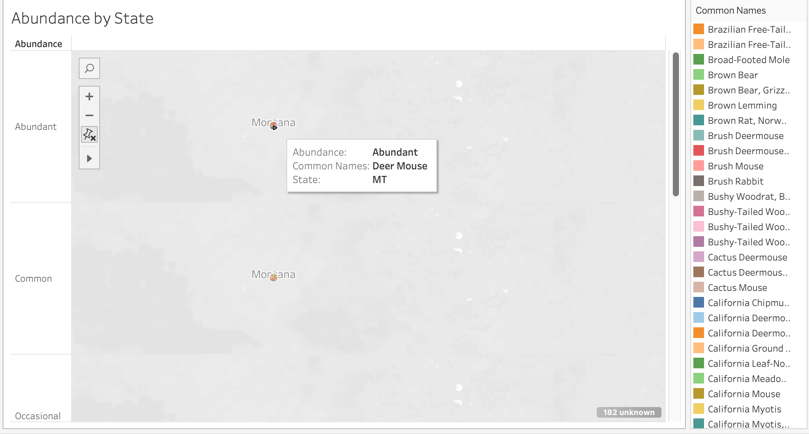

*Abundance by State (1)*



*Abundance by State (*2)



*Nativeness (3)*

*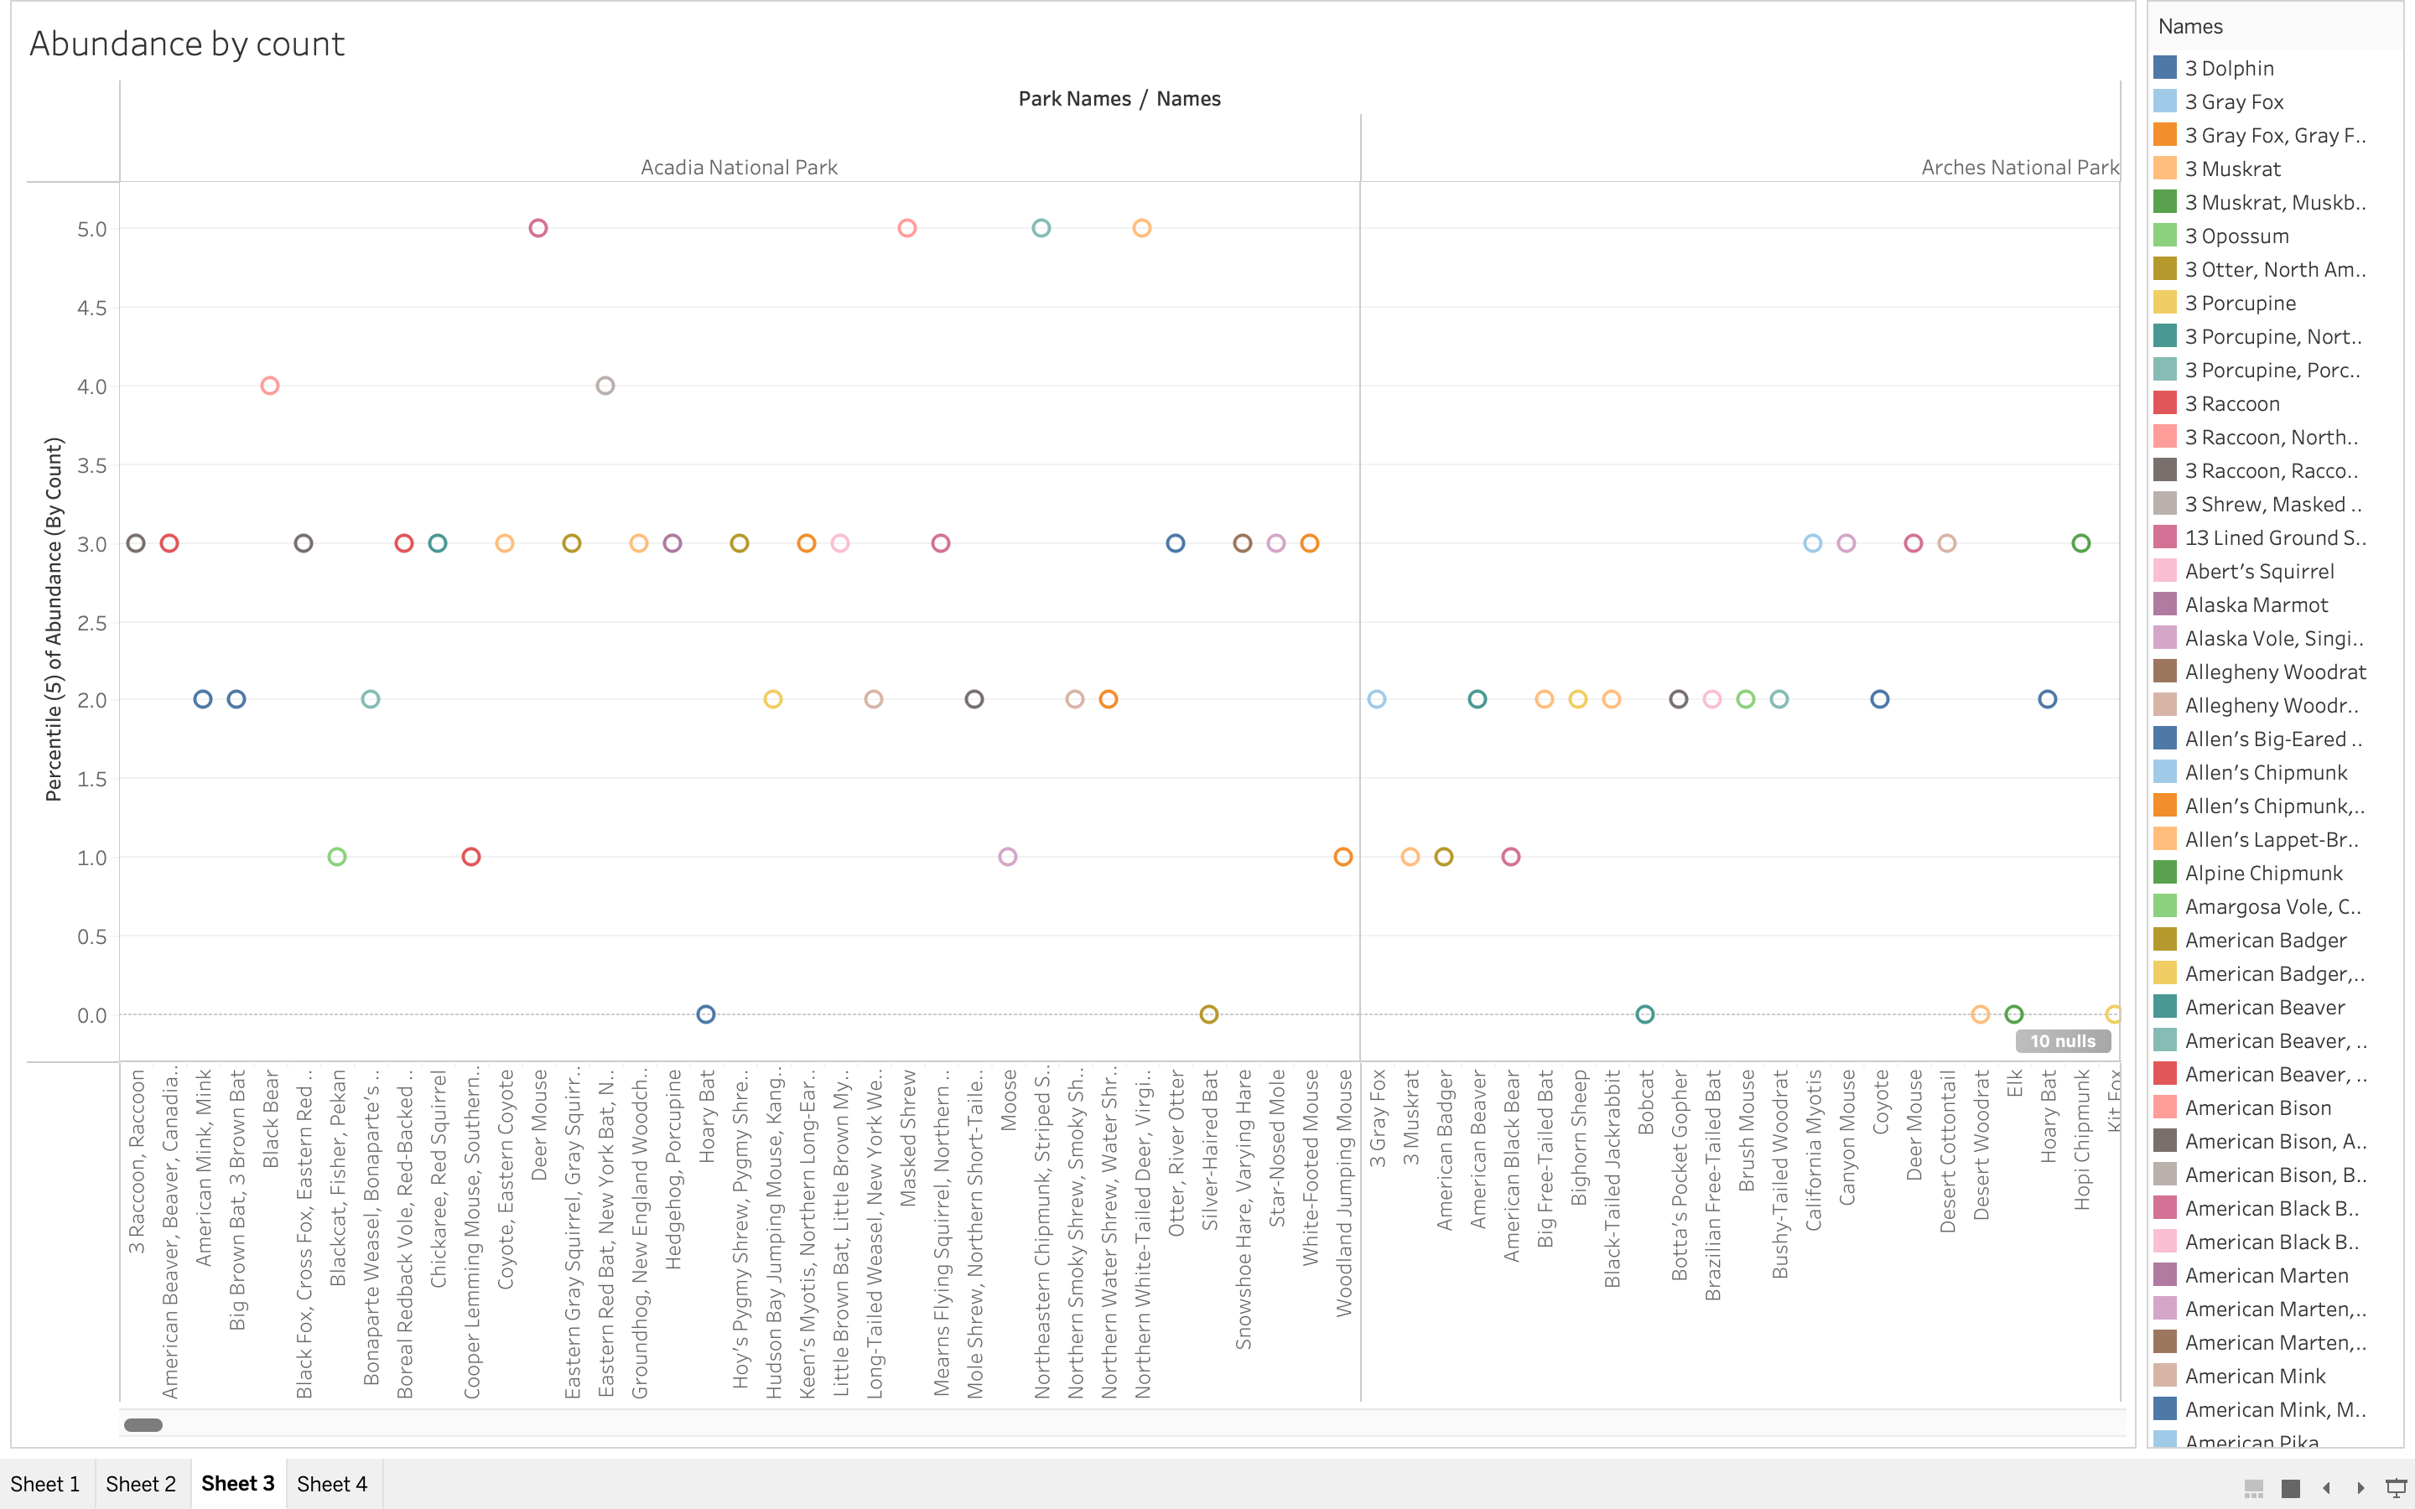*

*Abundance by Count (4)*

**

*Common animals found in each National Park (5)*

Works Cited

National Park Service. *Biodiversity in National Parks*. www.kaggle.com/datasets/nationalparkservice/park-biodiversity?resource=download&select=parks.csv.

“NPSpecies.” *National Park Service U.S. Department of the Interior*, irma.nps.gov/NPSpecies/Search/SpeciesList. Accessed 8 Dec. 2022.